**Unit 2 | Assignment - The VBA of Wall Street**

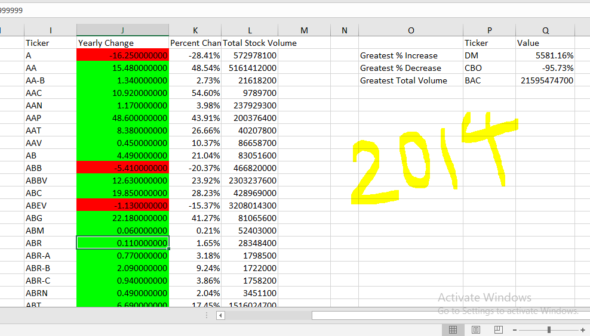

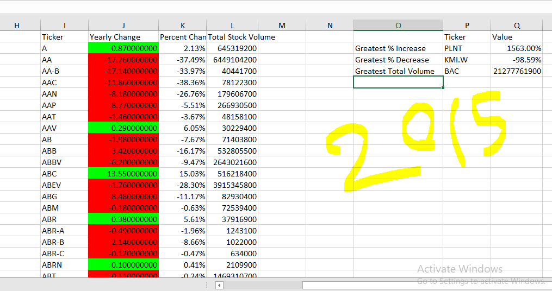

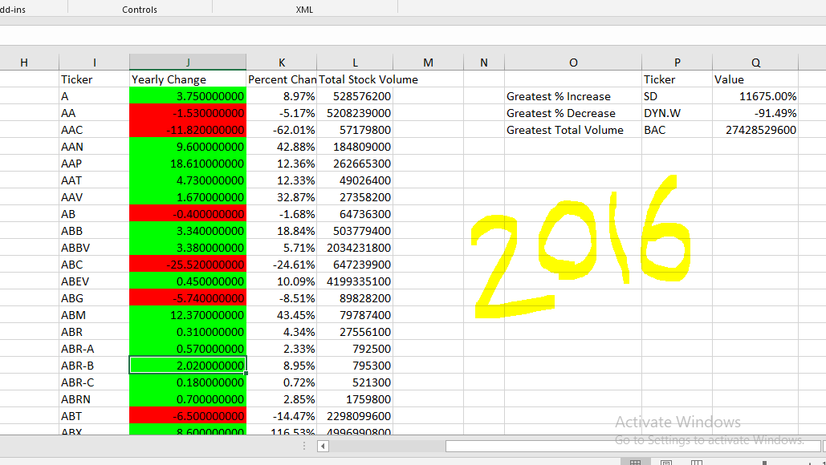

**VBA script**

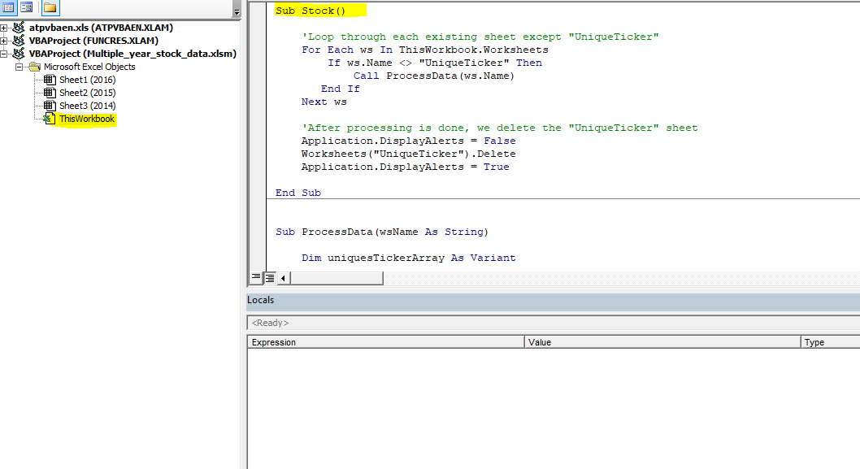

Sub Stock()

'Loop through each existing sheet except "UniqueTicker"

For Each ws In ThisWorkbook.Worksheets

If ws.Name <> "UniqueTicker" Then

Call ProcessData(ws.Name)

End If

Next ws

'After processing is done, we delete the "UniqueTicker" sheet

Application.DisplayAlerts = False

Worksheets("UniqueTicker").Delete

Application.DisplayAlerts = True

End Sub

Sub ProcessData(wsName As String)

Dim uniquesTickerArray As Variant

Dim ticker As String, sumVol As Double

Dim FirstOpeningPrice, LastClosingPrice, YearlyChange As Double

With Worksheets(wsName)

' --------------------------------------------

'Set Header

' --------------------------------------------

.Range("I1").Value = "Ticker"

.Range("J1").Value = "Yearly Change"

.Range("K1").Value = "Percent Change"

.Range("L1").Value = "Total Stock Volume"

.Range("O2").Value = "Greatest % Increase"

.Range("O3").Value = "Greatest % Decrease"

.Range("O4").Value = "Greatest Total Volume"

.Range("P1").Value = "Ticker"

.Range("Q1").Value = "Value"

.Range("Q2").NumberFormat = "0.00%"

.Range("Q3").NumberFormat = "0.00%"

.Range("Q4").NumberFormat = "0"

End With

' ------------------------------------------------------

' This funtion returns an array of all the unique Ticker

' ------------------------------------------------------

uniquesTickerArray = Filter_UniquesTicker(wsName)

For i = 1 To UBound(uniquesTickerArray)

ticker = uniquesTickerArray(i, 1)

With Worksheets(wsName)

' --------------------------------------------

' Filter Data by Ticker

' --------------------------------------------

.Range("A:A").AutoFilter Field:=1, Criteria1:=ticker

Set volumeRange = .Range("G2", .Range("G2").End(xlDown)).SpecialCells(xlCellTypeVisible)

Set openPriceRange = .Range("C2", .Range("C2").End(xlDown)).SpecialCells(xlCellTypeVisible)

lRow = .Cells(Rows.Count, 1).End(xlUp).Row

FirstOpeningPrice = openPriceRange(1, 1)

LastClosingPrice = .Range("F" & lRow).Value

YearlyChange = LastClosingPrice - FirstOpeningPrice

'Ticker

.Range("I" & i + 1) = ticker

'Yearly Change

.Range("J" & i + 1).NumberFormat = "0.000000000"

.Range("J" & i + 1) = YearlyChange

.Range("J" & i + 1).Interior.ColorIndex = IIf(YearlyChange < 0, 3, 4) '3 =Red, 4=Green

'Percent Change

If FirstOpeningPrice > 0 Then

.Range("K" & i + 1) = YearlyChange / FirstOpeningPrice

Else

.Range("K" & i + 1) = YearlyChange

End If

.Range("K" & i + 1).NumberFormat = "0.00%"

'Total Stock Volume

.Range("L" & i + 1) = WorksheetFunction.Sum(volumeRange)

.Range("L" & i + 1).NumberFormat = "0"

End With

Next

Worksheets(wsName).ShowAllData

Dim gI, gD, maxVolume As Double

With Worksheets(wsName)

'Greatest % Increase

gI = Application.WorksheetFunction.Max(.Range("K:K"))

gI = Format(gI, "0.00%")

Set gCell = .Range("K:K").Find(what:=gI, LookIn:=xlValues, lookat:=xlWhole)

.Range("P2").Value = .Range("I" & gCell.Row).Value

.Range("Q2").Value = gI

'Greatest % Decrease

gD = Application.WorksheetFunction.Min(.Range("K:K"))

gD = Format(gD, "0.00%")

Set dCell = .Range("K:K").Find(what:=gD, LookIn:=xlValues, lookat:=xlWhole)

.Range("P3").Value = .Range("I" & dCell.Row).Value

.Range("Q3").Value = gD

'Greatest Total Volume

maxVolume = Application.WorksheetFunction.Max(.Range("L:L"))

Set maxCell = .Range("L:L").Find(what:=maxVolume, LookIn:=xlValues)

.Range("P4").Value = .Range("I" & maxCell.Row).Value

.Range("Q4").Value = maxVolume

End With

End Sub

' ------------------------------------------------------

' This funtion returns an array of unique Tickers

' ------------------------------------------------------

Function Filter_UniquesTicker(wsName As String) As Variant

Dim uniqueSheet As String

uniqueSheet = "UniqueTicker"

Dim wsUnique As Worksheet

'"UniqueTicker" sheet is an extra place holder to copy the unique ticker data over.

'If "UniqueTicker" sheet does not exsist then we create it.

If Not WorksheetExists(uniqueSheet) Then

Set wsUnique = ThisWorkbook.Sheets.Add(After:=ThisWorkbook.Sheets(ThisWorkbook.Sheets.Count))

wsUnique.Name = uniqueSheet

Else

Set wsUnique = Worksheets(uniqueSheet)

End If

Dim uniquesArray As Variant

Dim lastRow As Long

With wsUnique

Worksheets(wsName).Columns("A:A").AdvancedFilter Action:=xlFilterCopy, CopyToRange:=.Range("A1"), Unique:=True

lastRow = .Cells(.Rows.Count, "A").End(xlUp).Row

'Save "UniqueTicker" data into an array

uniquesArray = .Range("A2:A" & lastRow)

.Columns("A").ClearContents

End With

Filter_UniquesTicker = uniquesArray

End Function

' ---------------------------------------------------------------

' This funtion checkes to see a sheet with the name exists or not

' ---------------------------------------------------------------

Function WorksheetExists(shtName As String, Optional wb As Workbook) As Boolean

Dim sht As Worksheet

If wb Is Nothing Then Set wb = ThisWorkbook

On Error Resume Next

Set sht = wb.Sheets(shtName)

On Error GoTo 0

WorksheetExists = Not sht Is Nothing

End Function